
Be a computing expert!
Computing Curriculum – Intent and Implementation

At Church Hill Infant School we recognise the importance of technology and how it is always evolving. We understand how technology plays a big part in children’s lives and how we must keep adapting our teaching to suit the ever-changing world of technology. Our Computing curriculum allows children to learn key skills in coding, word processing, photography and basic computer skills. Technology is introduced in the foundation stage through exploring and play. These experiences are then built upon in the next two years where children are taught more specific skills with a focus on the year group topic. Many Computing lessons are woven with other subjects to maximise learning opportunities. We are a school that is proud to have an award for e-safety and we recognise the huge importance of educating children to be confident with using technology safely. We want children to know what some of the risks are and what to do if they do come across a difficult situation. We ensure e-safety is taught regularly through assemblies, celebrating safer internet day and informing our parents of the latest updates.
Oracy
It is key that our young learners are able to communicate well with their classmates. In computing teamwork is vital and children require the skills to be able to talk to their partner in order to work together successfully. There is a lot of subject specific vocabulary in computing and it is important that children can use these words in the correct context. Computing requires a lot of trial and error and having the ability to discuss what has worked well and what has not worked will support them to become a computing expert.
SEND
We believe that every child should be respected as an individual and has the right to learn and develop their talents and abilities (Article 29). We adapt the curriculum and supply resources to suit pupils individual needs, including; social, emotional and mental health, physical, sensory and cognitive, so that every child can access the curriculum and further their learning. Children with complex needs including children with autism and social communication needs access the curriculum at their own level of personal development. This may not follow the continuum due to their individual learning profile, therefore they may not necessarily access all aspects of the progression map in order. For example, in reading, a child may be able to read complex texts, but not have the comprehension skills to match. We use our computing resources to support children in other areas of the curriculum such as using the voice memo app or typing up ideas in writing and accessing interactive content to support reading. Therefore computing is an area in which children with SEN often feel they are skilled and are more likely to feel a real sense of achievement.

Coding - skills and knowledge
EYFS | Year 1  Summer Unit – Programming Animation | Year 2  Summer Unit – Programming Quizzes
Reception  Show resilience and perseverance in the face of a challenge.  ELG  Be confident to try new activities and show independence, resilience and perseverance in the face of challenges.  I know that when I press something there will be a reaction to it.  I know how to programme simple instructions into a robot. | Understand what algorithms are and how they are implemented on digital devices.  I can plan a simple program.  To create more than one program for the same route.  I know what an algorithm is.  I know how to program a robot correctly giving it more than one instruction.  I know the correct order of commands in my algorithm.  I know that there is more than one possible route a robot can take. | Use logical reasoning to predict the behaviour of simple programs.  Understand that I can use the same commands but in a different sequence to create a new algorithm.  Create and debug simple programs.  I know where a robot will end up after following a series of instructions.  I know if my instructions have been successful or unsuccessful.  I know how to make changes to my instructions if they are incorrect.  I know I can create different algorithms using the same commands.
Robot, press, button, forwards and backwards, turn, instruction. | Left and right, algorithm, program, command, sequence, solution and problem, route. | Predict, debug, ambiguous, unambiguous, successful and unsuccessful, series.
Using a computer - skills and knowledge
EYFS | Year 1  Technology Around Us  Autumn Unit | Year 2  Information Technology Around Us  Autumn Unit
3 and 4 year olds  Explore how things work  Match their developing physical skills to task and activities in the setting.  Reception  Show resilience and perseverance in the face of a challenge.  ELG  Safely use and explore a variety of tools and techniques, experimenting with design and function.  I know how to hold a tablet correctly.  I know how to navigate a tablet successfully. | Recognise common uses of information technology in the home and school environment.  I can use a keyboard to type effectively.  I know where the letters and common punctuation marks are on a keyboard.  I know that my work can be saved as a file. | Use technology purposefully to create, organise, store, manipulate and retrieve digital content.  Understand how technology can help us at home and at school.  I know that people use technology at work and at home.  I know that there are different apps and programmes that I can use to create digital content. E.g PicCollage
Tablet, home screen, explore, app, press, button, volume | type, keyboard, computer, digital | programme, digital content
Be an E-safety expert- skills and knowledge on going thread throughout the year
EYFS | Year 1 | Year 2
3 and 4 year olds  Remember rules without needing an adult to remind them.  Reception  Know about sensible amounts of ‘screen time’  ELG  Explain the reasons for rules, know right from wrong and try to behave accordingly.  I know that I should only be online with an adult present.  I know that I can speak to an adult if I see something I don’t like online.  I know that I should only use a screen for a certain amount of time. | Own my Creative Work – Autumn 1  Safe Image Searching – Autumn 2  Staying SMART Online – Spring 1  My Personal Information – Spring 2  What is an Email? – Summer 1  Keeping Zib Safe Online – Summer 2  I can create, name and date my digital creative work – Autumn 1  I can safely search for images online – Autumn 2  I understand how to communicate safely online – Spring 1  I understand what personal information I need to keep safe. – Spring 2  I can explore how to use email to safely communicate – Summer 1  I can apply my online safety knowledge to help others make good choices online – Summer 2 | Digital Footprints – Autumn 1  Keywords - Autumn 2  You be the Judge – Spring 1  Rate and Review – Spring 2  Being Kind Online – Summer 1  Cyber Snakes and Ladders – Summer 2  I can understand that the information I put online leaves a digital footprint – Autumn 1  I can use keywords in an online search to find out about a topic – Autumn 2  I can recognise whether a website is appropriate for children – Spring 1  I can rate and review informative websites. – Spring 2  I am able to identify kind and unkind behaviour – Summer 1  I can apply my knowledge of safe and sensible online activities to different situations – Summer 2
Online, adult, screen time, safely. | Personal information, games, permission, email, communicate, searching | Download, accept, honest, private, digital footprint, appropriate. inappropriate, cyberbullying
Digital Literacy – Skills and Knowledge
EYFS | Year 1  Digital Painting  Spring Unit | Year 2  Digital Photography  Spring Unit
Reception  Develop small motor skills so they can use tools competently, safely and confidently.  Explore, use and refine a variety of artistic effects to express ideas and feelings  ELG  Safely use and explore a variety of tools and techniques, experimenting with design and function.  I know how to explore various apps and programmes. | Use technology purposefully to create digital content.  I can save my work and then open it from its saved location.  I can use different tools to create digital art. E.g size of brush, fill and shapes  I know that my work can be saved as a file.  I know how to locate my work and edit it.  I know how to find and use a variety of appropriate tools. | I understand what makes a good digital photograph. E.g orientation, lighting, distance  I understand that I can use tools to edit a digital photograph.  I can explain how a photograph could be improved.  I know what devices take photographs and which ones don’t.  I know how to take a good photograph using a digital device.  I know how to edit a digital photograph using tools e.g filters.
App | Save, open, tools, edit, file, digital | Portrait, landscape, flash, filter, digital photograph, improve, device, focus, framing

Computing Glossary

Coding

Coding
Coding is the language used to give instructions to computers.
Sequence
This is a set of step by step instructions created so a computer can do a task.
Algorithm
An algorithm is a set of instructions for a computer split into little steps.
Robot
A machine capable of carrying out a complex set of actions automatically.
Debug
To debug is to fix a sequence in a computer programme.
Instruction
An instruction is telling someone or something how to do something

Command
A command is telling someone or something to do something straight away.
Route
A route is the way someone or something uses to get somewhere.
Predict
Predict means to guess what you think will happen next.
Series
A series is when things happen one after another.

Using a Computer
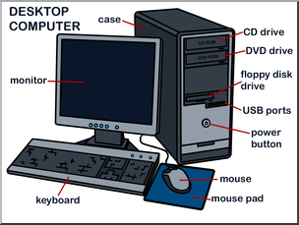

Computer
A computer is an electronic device capable of storing and processing data. e.g desktop computer, laptop, tablet
Information technology
Information technology is a computer of something that works with a computer e.g laptop, digital camera, smart speaker
Digital Content
Digital content is anything that is represented in digital form. e.g digital photo, website, Powerpoint

Apps
App is short for application. It is a programme that can be downloaded onto a mobile device e.g Pic Collage, Tik Tok, Spotify
Button
A button is something you can click or tap to make a computer do something.
Type
Type means to press the buttons on a keyboard to write words.
Keyboard
A computer keyboard is a set of buttons you press to type letters, numbers, and symbols on a computer.

Digital Literacy

Electronic File
An electronic file is any media that is designed to be viewed in digital form or printed e.g photo, word document, digital painting
Tools
Tools in apps are buttons that are used to carry out an instruction e.g rubber, background fill
Save
Save means to keep your work safe so you can look at it later.
Programme
A programme is something on a computing that can be used to do a job such as the camera or paint.
Tools
Tools are things on a computer that help you do a job.
Edit
Edit means to change something on a computer.
Portrait
Portrait is a picture of person like when you draw a face. Portrait also means when a picture or page is taller than wider.
Landscape
Landscape means a big, wide view of something. Landscape also means when a picture or page is wider than taller.
Flash
A flash is a bright light that helps you see things better when taking a photo.
Filter
A filter is something that changes a way a photo looks, like making the colour brighter or turning everything a funny colour.
Focus
Focus means making something in a photo look clear and sharp.
Framing
Framing is when you use things around you, like trees or doors to make a photo look nice.
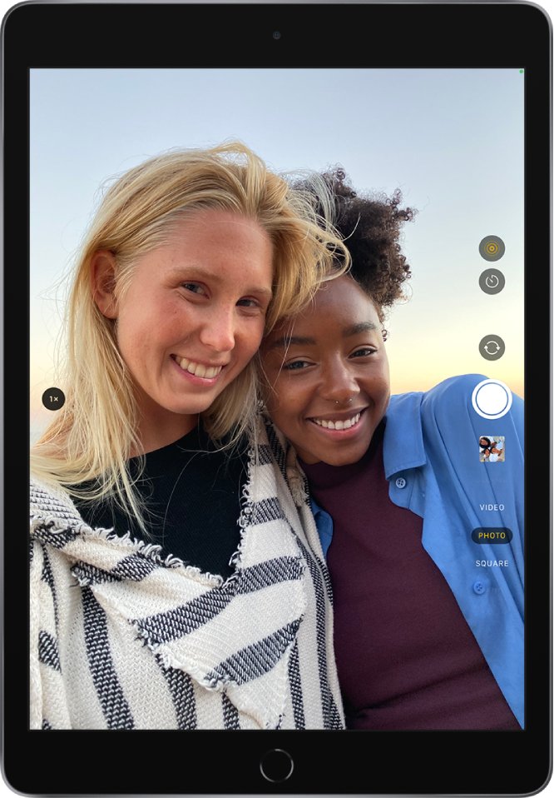

Flash
Timer

Switch camera from back to front or vice versa
Capture
Last photo taken

Different options e.g video, panoramic, square

E-safety

Digital Footprint
A digital footprint is the information that exists about any given person on the internet e.g search history, social media posts.
Social Media
Social media is any app or program that allows people to make and share content with others digitally.
Screen time
Screen time is how long any given person is using a digital device.
The current advice suggests that children aged from 5 to 17 should limit their screen time to 2 hours a day.
Download
Downloading is when you copy something from one computer to another.
Virus
A virus is computer code that is capable of copying itself and corrupting or destroying data.
Online
Online means being connected to the internet, like when you play a game or watch a video on the computer.
Trusted Adult
A trusted adult is someone over the age of 18 that you know well, like your mum and dad or a teacher.
Personal Information
Personal information are the things about you that are private, like your name, address or birthday.
Permission
Permission means asking if it’s ok to do something, like playing a game on a computer or watching a video.
Cyberbullying
Cyberbullying is when someone is mean to another person on the computer or phone.

