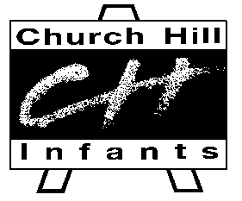
Be an Artist!
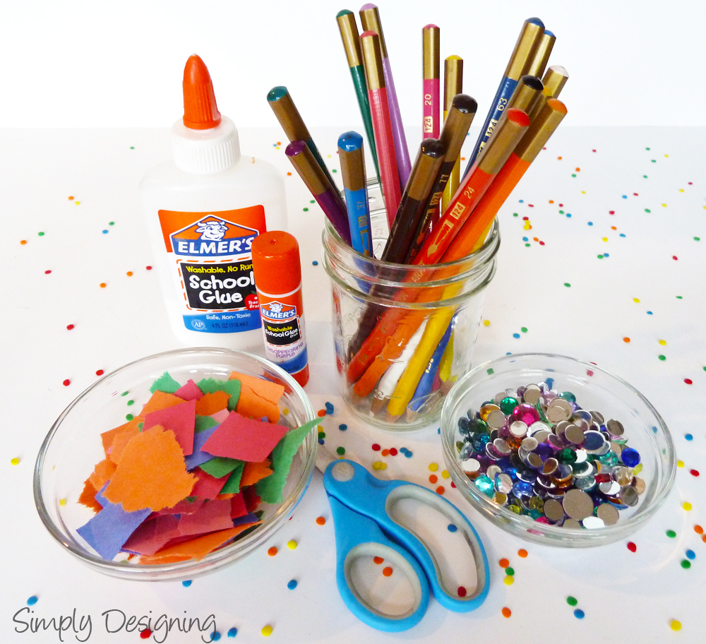

Art and Design Curriculum – Intent and Implementation
We believe that art is a vital part of a child’s education. A high-quality art and design education should engage, inspire and challenge pupils, equipping them with the knowledge and skills to experiment, invent and create their own works. As pupils progress they should be able to think critically and develop a more rigorous understanding of art and design. They should also know how art and design both reflect and shape our history, and contribute to the culture, creativity and wealth of our nation. Creativity is an important part of our curriculum, and we encourage children to think and work independently with the influence of a range of artists. Each pupil should be given opportunities to experiment with different effects, and have the freedom to create and express themselves whilst being taught how to use different media and techniques appropriately.
Our Art and Design Curriculum focuses on the skills and knowledge outlined in the National Curriculum; children will acquire their practical knowledge and skills through production of artwork and will understand more about art and design through focused learning on the different artists and art over time. Although children will be taught a broad range of skills during their time at the Infant School our golden thread will be a focus on drawing as we believe that drawing proficiently underpins all other art skills and techniques. Our curriculum ensures progression across the Early Years Foundation Stage and Key Stage 1 by revisiting and refining skills year on year.
Oracy is a key focus for our school – we aim to develop Literacy skills across the curriculum and ensure pupils can be reflective artists. Topics are reviewed on a yearly basis to ensure relevance for the current cohort, and to encourage reflective practise. There is no set formula for the Art and Design curriculum, and there is flexibility in the long-term plan to reflect the needs and cultural capital of the pupils.

SEND
We believe that every child should be respected as an individual and has the right to learn and develop their talents and abilities (Article 29). We adapt the curriculum and supply resources to suit pupils individual needs, including; social, emotional and mental health, physical, sensory and cognitive, so that every child can access the curriculum and further their learning. Children with complex needs including children with autism and social communication needs access the curriculum at their own level of personal development. This may not follow the continuum due to their individual learning profile, therefore they may not necessarily access all aspects of the progression map in order. For example, in reading, a child may be able to read complex texts, but not have the comprehension skills to match. Due to the possible sensory needs of children with autism and social communication difficulties, some children may find it challenging to participate in messy play and activities- this will be accounted for in the provision and teaching and learning.
Experiment, invent and create - skills and knowledge
EYFS |  | Year 1 | Year 2
3 - 4 year olds  Explore different materials freely, in order to develop their ideas about how to use them and what to make.  Reception  Explore, use and refine a variety of artistic effects to express their ideas and feelings  I can join different materials and explore different textures.  I can explore texture, form and function.  I know that different materials, tools and techniques create different effects. |  | I can experiment with different media such as paint, oil pastels, charcoal, chalk, clay.  I can design artwork and products in 2 and 3 dimensions such as paintings, drawings, sculpture (small and large scale).  I know the name of different media such as paint, oil pastel, charcoal, chalk, clay.  I know what media would be appropriate to use on 2 and 3 dimensional designs. | I can experiment with tones using different grades of pencils, chalks and charcoal.  I can experiment with using basic tools appropriately on rigid and flexible materials (see also DT curriculum) such as using a paintbrush on different surfaces.  I can experiment with space in my artwork and when designing a 3-dimensional piece.  I know that grades of pencils create different tones.  I know that tone means how light or dark a colour is.  I know the difference between a rigid and flexible material.  I know that space in art means where I place the main focus of my artwork and the space around it.  I know that space in sculpture/3-dimentional designs in the space around my artwork when it is displayed.
Vocab  Join, texture, create |  | Vocab  Experiment, paint, oil pastel, charcoal, chalk, clay, 2D, 3D, drawing, sculpture, product, joining, weaving | Vocab  Tone, light, dark, graded pencils, rigid, flexible, surface, space, display
Artistic Communication - skills and knowledge
EYFS |  | Year 1 | Year 2
3 – 4 year olds  Develop their own ideas and then decide which materials to use to express them.  Show different emotions in their paintings and drawings such as happiness, sadness, fear etc.  Reception  Return to and build on their previous learning, refining ideas and developing their ability to represent them.  ELG  Share their creations, explaining the process they have used.  I know that I can use my own ideas when creating artwork.  I know that some colours and shapes can be related to moods and feelings. |  | I can name some artists, and make observations about their work.  I can talk about what I like and dislike about a piece of art.  I know that an artist is somebody who creates artwork.  I know that artists create artwork in different styles and mediums. | I can compare the work of different artists.  I can talk about why I have chosen to use a technique.  I can talk about my work, and think of ways I could improve it next time.  I can talk about what I like and dislike about a piece of art and give reasons for my answer.  I can describe the differences and similarities between different practices and disciplines (Dance, Media Arts, Music, Theatre, and Visual Arts).  I know that artists create artwork for different purposes.  I know the names of some different practices and disciplines (dance, media arts, music, theatre and visual arts).
Vocab  Material, feeling, emotions, colour, explain, idea, artwork |  | Vocab  Artist, like/dislike, create, artwork, style, medium | Vocab  Artists, technique, artwork, improve, similarity, difference, dance, media arts, music, theatre, visual arts.
Drawing - skills and knowledge (taught throughout the year)
EYFS |  | Year 1 | Year 2
3 - 4-year olds  Draw with increasing complexity and detail, such as representing a face with a circle and including details.  Create closed shapes with continuous lines, and begin to use these shapes to represent objects.  Use drawing to represent ideas such as movement or loud noises.  Reception  Develop their small motor skills to use a range of tools competently, safely and confidently.  ELG: Creating with Materials  Safely use and explore a variety of materials, tools and techniques, experimenting with colour.  I can hold a pencil effectively.  I can begin to show accuracy and care when drawing.  I know that shapes can be used to represent subjects that I’m drawing.  I know that pencils are used for writing and drawing |  | I can use simple shapes to represent what I observe such as a flower, house, person.  I can use a range of marks to represent a range of texture or forms such as zig zags, dashes, spots or waves.  I can represent light and dark using a series of lines such as hatching, cross hatching or stippling.  I can draw with different media such as graphite stick, charcoal, crayons and coloured pencils.  I know the names of techniques that I use in my drawing such as sketching, shading, shape, line, marks.  I know different media can be used to create different thicknesses and tone of marks.  I know texture and pattern can be created using different marks and lines. | I can use shapes purposefully and accurately when doing observational drawing (draw what I see rather than what I imagine).  I can create lighter and darker tones using varying pressure, marks and graded pencils.  I can shade areas with greater accuracy without spaces and gaps.  Identify and draw detailed texture and pattern using different marks.  I can consider the sizes of subjects in relation to one another.  I know that texture, tone and pattern can be created using a variety of mark making techniques.  I know that I can add detail to my work using texture, tone and pattern.
Vocab  Draw, pencil, imagination, observation, memory, shape, line, mark, shape, symbol, represent |  | Vocab  Shape, represent, mark, texture, form, light and dark, hatching, cross hatching, stippling, graphite stick, charcoal, crayon, coloured pencil, sketch, shade, broad, thick, thin, straight, curved, zig-zag, hard, soft | Vocab  Sketch, shadow, accurate, proportion, observational, shade, pressure, graded pencils, B, HB, contrast, blend, tone, accuracy, detail, texture, pattern.
Painting - skills and knowledge
EYFS |  | Year 1 | Year 2
Reception  Explore colour and colour mixing.  ELG  Safely use and explore a variety of materials, tools and techniques, experimenting with colour, design and form.  I know how to hold a paintbrush effectively.  I know the primary colours (red, yellow and blue).  I know that colours mix together to make new colours.  I know the link between the size of the brush and the brushstrokes they make.  I know the names of poster and powder paint. |  | I can explore using different size brushes and understand the effect they have.  I can explore and know that the texture of paint can be changed by adding mediums such as sand, grit or salt.  I can mix colours to make secondary colours and tints, shades and tones.  I can use poster paint and watercolour to create artwork.  I know primary colours make secondary colours (Red + Yellow = Orange, Blue + yellow = green, Red + Blue = Purple).  I know that adding white will create a tint.  I know that adding black will create a shade.  I know that adding grey will create a tone.  I know the names of poster paint and watercolour paint (block paint). | I can use different techniques such as spattering, stippling, dripping or pouring to paint expressively.  I can mix colours effectively for different purposes.  I can experiment with creating mood with colour.  I can experiment with painting on a range of surfaces such as cartridge paper, card, brown paper, coloured papers, textured surfaces.  I know different brushes and brush strokes/techniques will create different effects.  I know that tertiary colours can be made by mixing primary and secondary colours (Red + Orange, Orange + Yellow, Yellow + Green, Green + Blue, Blue + Purple, Purple + Red).  I know how watercolour paints differ from poster paints (viscosity, different form –pre mixed/requires mixing, effect).
Vocab  Paint, paint brush, brushstroke, thick, thin, big, small, colour, primary colour, red, blue, yellow, apply, mix, size, poster paint, powder paint. |  | Vocab  Effect, texture, smooth, rough, medium, secondary colours, orange, green, purple, tint, black, white, grey, tone, shade, poster paint, watercolour paint, lighter, darker | Vocab  Spattering, stippling, dripping, pouring, expressively, colour mixing, purpose, experiment, brush strokes, mood, cool colours, warm colours, surface, cartridge paper, card, brown paper, coloured paper, textured surface, tertiary colours
Sculpture - skills and knowledge
EYFS |  | Year 1 | Year 2
ELG  I can join simple objects together with support.  I can use simple casting methods such as jelly moulds, sand bucket etc.  I can explore junk modelling.  I know a 3D object is not flat.  I know 3D objects are best made out of malleable materials such as playdoh, wet sand, clay, kinetic sand.  I know how to use a mould. |  | I can use shapes to represent a design.  I can use a variety of material to create a 3D design such as rolled up paper, straws, card, junk items.  I can use techniques such as rolling and cutting.  I know that a 3D object has height, width and depth.  I know different ways of joining materials such as stick glue, PVA glue, Sellotape, string. | I can use line and texture in my art piece.  I can use techniques such as moulding and carving.  I can use different modelling tools to create different effects on clay.  I can use clay and other mouldable materials with purpose.  I know that sculptures are 3D art.  I know that clay must be worked on quickly as it will dry out.  I know that different tools will create different effects.
Vocab  Shape, mould, model, form, flat, playdoh, wet sand, clay, kinetic sand |  | Vocab  Represent, rolled paper, straw, card, junk model, height, width, depth, change, join | Vocab  Line, texture, model, carve, modelling tools, clay, Plasticine, dry, wet, effect, solid, manipulate
Collage - skills and knowledge
EYFS |  | Year 1 Focus | Year 2
I can handle different material and explore ways of manipulating them such as cutting, tearing.  I can sort and select materials for a purpose.  I can cut a variety of materials.  I know that collage is the sticking of materials together to create an image.  I know that I can rip for collage as well as use scissors.  I know that different sources can be used to create a collage such as magazine, newspaper, fabric. |  | I can sort and arrange materials for effect.  I can mix materials to create texture.  I can use a combination of materials that are cut, torn, folded, crumpled, overlapped and glued.  I can cut and tear with confidence and control.  I can select appropriate materials considering colour, shape and texture.  I can look at my piece of work and make any changes needed such as adding paint, adding texture, filling gaps  I know that paper can be overlapped and layered to fill a space.  I know that collage is the sticking of materials together to create an image.
Vocab  Material, image, cut, tear, rip, sort, glue, attach, stick, scissors, magazine, newspaper, fabric |  | Vocab  Sort, material, effect, mix, texture, combine, cut, tear, fold, crumple, overlap, glue, shape, texture, layer, collage, arrange, rearrange
Printing - skills and knowledge
EYFS |  | Year 1 | Year 2 Focus
I can print with a variety of objects  I can apply ink or paint to a surface  I can press hard to transfer the ink or paint  I know that orienting is the process of creating an image by transferring ink or paint from a printing source to paper such as sponge, natural material, fruit, pre made stamps.  I know that printing happens in everyday life such as in books, newspapers, posters, t-shirts, lunch boxes, classroom resources |  |  | I can use objects and/or materials to create prints such as card, string, foam, textured material.  I can press, roll, rub and stamp to make prints.  I can use repeating or overlapping shapes.  I can create a simple printing block with support.  I can use a range of printing techniques such as mono printing, block printing, relief printing.  I can apply ink or paint evenly and reapply as needed.  I can apply even pressure with hands or a roller to create a print.  I know that a printing block is a design that can be used over and over to create the same image.  I know the names of different printing techniques.
Vocab  Print, indent, press, push, apply, ink, roller, transfer, image, object, surface, hard, sponge, natural material, fruit, stamp, book, newspaper, t-shirt, lunch box, classroom resources |  |  | Vocab  Card, string, foam, textured material, rub, roll, stamp, print, repeating, overlapping, block print, ink, ink roller, reapply, even pressure, roller, detail, precise, line-up, evenly
Glossary of terms
Experiment, invent and create
Texture - How something feels when you touch it.  Create - To make something new. |  | Experiment - To try something new and see what happens.  Oil pastel - A smooth, colourful crayon that feels a little soft.  Chalk - Chalk is a soft stick you can draw with, usually white or in colours. | Tone - How light or dark a colour or shade is.  Graded pencil - A pencil with a special letter or number that shows how light or dark it can draw.
Artistic communication
Artwork - A special thing you make to show to people. Feeling - How your body or heart feels like happy, sad, tired, or excited. |  | Artists - People who make art like drawings, paintings, or sculptures.  Like - When something makes you happy or excited.  Dislike - When you don’t enjoy something. | Technique - A special way of doing something in art.  Improve - To make something better than it was before.
Drawing
Draw - To make a picture with a pencil, crayon, or pen.  Line - A long mark that goes straight, wiggly, or curly.  Shape - A flat form like a circle, square, or triangle. |  | Light - Bright and easy to see.  Dark - Not much light — it looks deeper or dimmer.  Thick - Something that is wide or big.  Thin - Something that is small or skinny.  Sketching - Drawing something quickly with light lines. | Pressure - How hard or soft you press with your hand or tool.  Blend - To mix colours or shades together so they look smooth.  Detail - The little things you add to make your art more interesting.
Painting
Paint - Colour you use with a brush to make pictures.  Paintbrush - A tool with soft hair for putting paint on paper.  Primary colour - Red, blue, and yellow, you can mix them to make new colours!  Mix - To stir things together to make something new. |  | Secondary colours - Colours made by mixing two primary colours. Orange (red + yellow), green (blue + yellow), and purple (red + blue).  Shade - A darker version of a colour.  Lighter - A colour that is more bright than another one.  darker - A colour that is deeper or closer to black. | Mood - How you feel inside.  Cool colours - Colours that feel calm or chilly — like blue, green, and purple.  Warm colours - Colours that feel hot or cosy — like red, orange, and yellow.  Brush strokes - The marks a paintbrush makes when you paint.
Sculpture
Mould - To squish and shape something soft.  Model - A thing you make to look like something else. |  | Join - To put two things together. | Texture - How something feels or looks like it would feel.  Model - A shape or figure you build, usually with your hands.  Carve - To cut into something to make shapes or pictures.
Collage
Cut - To use scissors to make pieces smaller.  Tear - To pull paper or fabric so it breaks.  Attach - To put two things together so they stay.  Stick - To make something stay on something else. |  | Overlap - When one thing goes on top of another.  Collage - A picture made by gluing pieces of paper, fabric, or photos together.  Arrange - To put things in a special order or place.  Rearrange - To move things around and put them in a new order.
Printing
Print - To press something on paper to leave a mark.  Stamp - A tool you press down to leave a picture |  |  | Block print - A picture made by pressing a carved block onto paper.  Ink - A coloured liquid used for printing or drawing.  Ink roller - A tool with a handle and a round part that rolls.
Adaptations to Support Learners with SEND
Cognition and Learning
Barriers | Provision
Remembering multi step instructions. | - Step by step reminders of key processes.  - Broken down success criteria with clear reminders.  Many children with learning difficulties are able to excel in art and technology therefore need to be aware of individual profile of need.
Communication and Interaction
Barriers | Provision
Understanding the vocabulary and descriptive language used. | - Capitalise on the opportunities to model and teach new vocabulary. Eg. “soft”, allow the child to feel it and repeat back the word soft.  - Provide key vocabulary for the child to choose from to scaffold their language.  - Label equipment with a picture/symbol and word (dual coding)  - Allow a choice between two using choice boards or Makaton if speech is significantly delayed. Encourage the verbal response and support with repeating the vocab ‘You’ve chosen soft – yes it is soft’.
Physical and/or Sensory
Barriers | Provision
Sensory issues working with certain materials such as clay.  Potential higher noise level/busier classroom during practical activities.  Accessibility of the equipment.  Child’s ability to use the equipment safely | - Use of alternative less messy equipment such as play dough  - Consider pupil sensory audits and adaptations  - Ensure that instructions are not given over a busy classroom so that they can be heard and understood.  - Ensure that equipment is stored and put away appropriately to aid access and to avoid trips or hazards for someone visually impaired.  - Provide adapted resources such as pencil grips, larger pencils, paintbrushes with appropriate grips, spring loaded scissors.  - Slanted surfaces and clips to grip the paper to the surface.  - Ensure that the child is near to the adult so that they can see/hear safety demonstrations.  - Use hand over hand approach to support/model appropriate safety.  - Allow more time for the use of tools and equipment – child may have their own to enable this rather than sharing with others.
Social, Emotional and Mental Health
Barriers | Provision
Less structured lesson format may make it harder for self-regulation behaviours.  Focus and attention on extended pieces of work | - Clear expectations in advance of the lesson and explanation of what is happening during the lesson.  - Time out or movement breaks if needed.  - Supported by resources which allow visual representation of self-regulation strategies eg. emotion thermometer etc.  - Allow movement breaks and incorporate alternative tasks to break the activity up into smaller chunks.  - Opportunities to develop social skills including being taught these discretely to support engagement in group work and collaborative learning.

