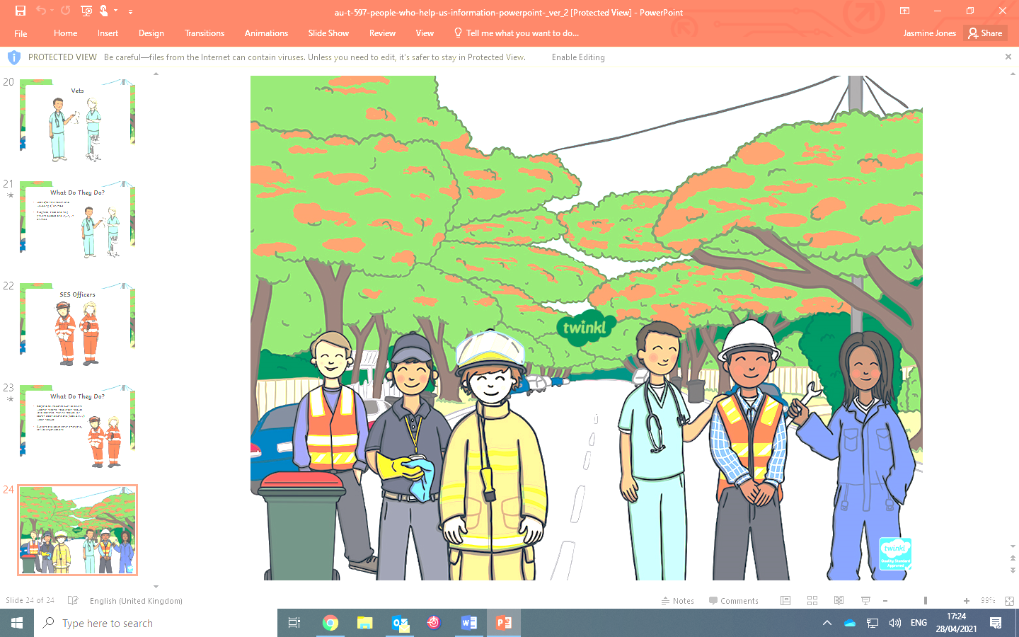

**Art and design**

**EA&D: Media and Materials: 40-60**

* Uses simple tools and techniques competently and appropriately.
* Selects tools and techniques needed to shape, assemble and join materials they are using.

**EA&D: Being Imaginative: 40-60**

* Introduces a storyline or narrative into their play.
* Plays alongside other children who are engaged in the same theme.
* Plays cooperatively as part of a group to develop and act out a narrative.

**ELG**

They represent their own ideas, thoughts and feelings through design and technology, art, music, dance, **role play and stories.** Children use what they have learnt about media and materials in original ways, thinking about uses and purposes.

**Personal, social and emotional development**

**PSED: Self-confidence and Self-awareness: 40 - 60**

* Confident to speak to others about own needs, wants, interests and opinions.
* Can describe self in positive terms and talk about abilities.

**ELG**

They are confident to speak in a familiar group, will talk about their ideas

**PSED: Managing Feelings and Behaviour: 40 – 60**

* Understands that own actions affect other people, for example, becomes upset or tries to comfort another child when they realise they have upset them.
* Aware of the boundaries set, and of behavioural expectations

**PSED: Making Relationships: 40 – 60**

* Explains own knowledge and understanding, and asks appropriate questions of others. in the setting.
* Beginning to be able to negotiate and solve problems without aggression, e.g. when someone has taken their toy.

**Literacy**

**Reading: 40-60**

Can segment the sounds in simple words and blend them together and knows which letters represent some of them.

Begins to read words and simple sentences.

Enjoys an increasing range of books.

**ELG**

Children read and understand simple sentences. They use phonic knowledge to decode regular words and read them aloud accurately. They also read some common irregular words. They demonstrate understanding when talking with others about what they have read.

**Writing: 40-60**

Begins to break the flow of speech into words.

Hears and says the initial sound in words. Can segment the sounds in simple words and blend them together.

Writes own name and other things such as labels, captions.

Attempts to write short sentences in meaningful contexts.

**ELG**

Children use their phonic knowledge to write words in ways which match their spoken sounds. They also write some irregular common words. They write simple sentences which can be read by themselves and others. Some words are spelt correctly and others are phonetically plausible.

**Communication and language**

**C&L: Speaking: ELG**

* They use past, present and future forms accurately when talking about events that have happened or are to happen in the future.
* They develop their own narratives and explanations by connecting ideas or events.

**Understanding: 40-60**

* Listens and responds to ideas expressed by others in conversation or discussion.

**Foundation Stage Summer 2021 People Who Help Us**

**Skills**

**Maths**

**Number 40-60**

* Counts objects to 10, and beginning to count beyond 10.
* Selects the correct numeral to represent 1 to 5, then 1 to 10 objects.
* Counts an irregular arrangement of up to ten objects.
* Counts out up to six objects from a larger group
* Uses the language of ‘more’ and ‘fewer’ to compare two sets of objects.
* Finds the total number of items in two groups by counting all of them
* In practical activities and discussion, beginning to use the vocabulary involved in adding and subtracting.
* Records, using marks that they can interpret and explain.

**ELG**

Children count reliably with numbers from one to 20, place them in order and say which number is one more or one less than a given number. Using quantities and objects, they **add** and subtract two single-digit numbers and count on or back to find the answer.

**We are going to be promoting our school values of…**

Excellence – trying to be our best

Determination – keeping on trying, even when it’s hard!

Teamwork – working together to resolve conflicts

Kindness – sharing with our friends

Being Unique – thinking about how our families are unique

**Physical Development**

**PD: Moving and Handling:40 – 60**

* Uses simple tools to effect changes to materials.
* Handles tools, objects, construction and malleable materials safely and with increasing control.

**PD: Health and Self-care: 40 – 60**

* Eats a healthy range of foodstuffs and understands need for variety in food.
* Shows some understanding that good practices with regard to exercise, eating, sleeping and hygiene can contribute to good health.
* Shows understanding of the need for safety when tackling new challenges, and considers and manages some risks.

**ELG**

Children know the importance for good health of physical exercise, and a healthy diet, and talk about ways to keep healthy and safe. Looks closely at similarities, differences, patterns and change.



**Understanding the world**

**UTW: People and communities:**

* Shows interest in different occupations and ways of life.
* Shows interest in the lives of people who are familiar to them

**ELG**

Children talk about past and present events in their own lives and in the lives of family members. They know about similarities and differences between themselves and others, and among families, communities and traditions.

**Art and design**

We will create representations of people who help us through learning various new techniques…

* Origami nurse/doctor (folding technique)
* Painting people who help us
* X-ray making (black paper, chalk, white paint and earbuds)
* Paint future self
* Junk modelling

**Personal, social and emotional development**

Children will have opportunities to discuss…

* What they’re good at
* What do they want to be good at?
* How to be kind and helpful
* How to help others
* What are our Church Hill values
* How other people help us
* Jobs and occupations
* How to make good choices
* What are good choices
* Dojo points!

**Literacy**

Children will...

* Learn how to read and write CVC words (consonant, vowel, consonant)
* Know what a sentence is and how to form one correctly using capital letters, finger spaces and full stops.
* Use techniques like ‘robot arms’ and using the sound mats to help them to apply their phonics to their writing.
* Learn how to read and write FS common exception words (tricky troll words)
* Begin to write words and then sentences independently using phonetically plausible attempts.
* Form their letters correctly, recognising which letters belong to the letter families.

**Communication and language**

Children will have the opportunity to…

* Discuss what they want to do when they grow up
* Talk about how they can help people
* Talk about what they have done in the near past (yesterday, last week, at the weekend)

**Foundation Stage Summer 2021 People Who Help Us**

**Skills**

**Maths**

Children will…

* Learn about addition and subtraction with objects such as Numicon, cubes, counters etc.
* Use tens frame to help to count accurately and understand numbers to 20
* Count forwards and backwards to 20 through songs, rhymes and rote counting.
* Order numbers to 20 including zero using number cards and constructing their own number line
* Play games such as snakes and ladders where they can practice their counting skills through dice and jumps.
* Use vocabulary relevant to adding and subtracting, greater than/fewer than, more/less and altogether/how many left.
* Use Numberblocks to explore numbers beyond 10.

**We are going to be promoting our school values of…**

Excellence – trying to be our best

Determination – keeping on trying, even when it’s hard!

Teamwork – working together to resolve conflicts

Kindness – sharing with our friends

Being Unique – thinking about how our families are unique

**Physical Development**

Children will have opportunities to…

* Explore dancing and responding to music
* Climbing, jumping and balancing in gymnastics
* Develop their fine motor skills through funky finger activities like threading, cutting and mark making.
* Form their letters correctly through guided and independent writing opportunities.
* To learn about healthy food choices and why exercising is important.
* Handle equipment safely like scissors, (child) hammers and pins.

**Understanding the world**

Children will talk with their adults at home about what jobs they do. They will create a profile with their grown-ups and bring it into school to discuss. Discuss jobs that family members do.

Talk about people who help us in the community eg. Bus drivers, cleaners, teachers, firefighters, police officers etc.