18th June 2021
Dear Parents / Carers,
ARBOR – Parent Communication App

In order to help both our school and our families, we have reviewed our current absence reporting, communication and payments system and have decided to move to a new combined system called “Arbor”. Please Note: this will be the only platform in use after the Summer Holiday, as we will be moving away completely from Studybugs and ParentPay.

The new system will be used for all electronic correspondence and therefore we would like to request that parents download the free App which is available on Android or IOS.
You should have received a welcome email direct from our Arbor system. This will contain your login details and a link that will take you to the browser version of the Parent Portal where you need to set up a password -you won't be able to do this through the App. You can also reset your password at any time using a computer, or using a mobile browser on your smart phone or tablet.
The Arbor App is the mobile version of our Parent Portal (you can log into the Parent Portal by going to login.arbor.sc from your laptop or PC and inputting your email address and password). The App is for use on mobile devices such as smartphones and tablets. The Parent Portal and Arbor App will let you book your child onto a school trip or a club, book parents evening slots, send a message to the school office, report your child as absent and manage payments all from either a computer or smart phone.

Download from Android: Download from IOS:
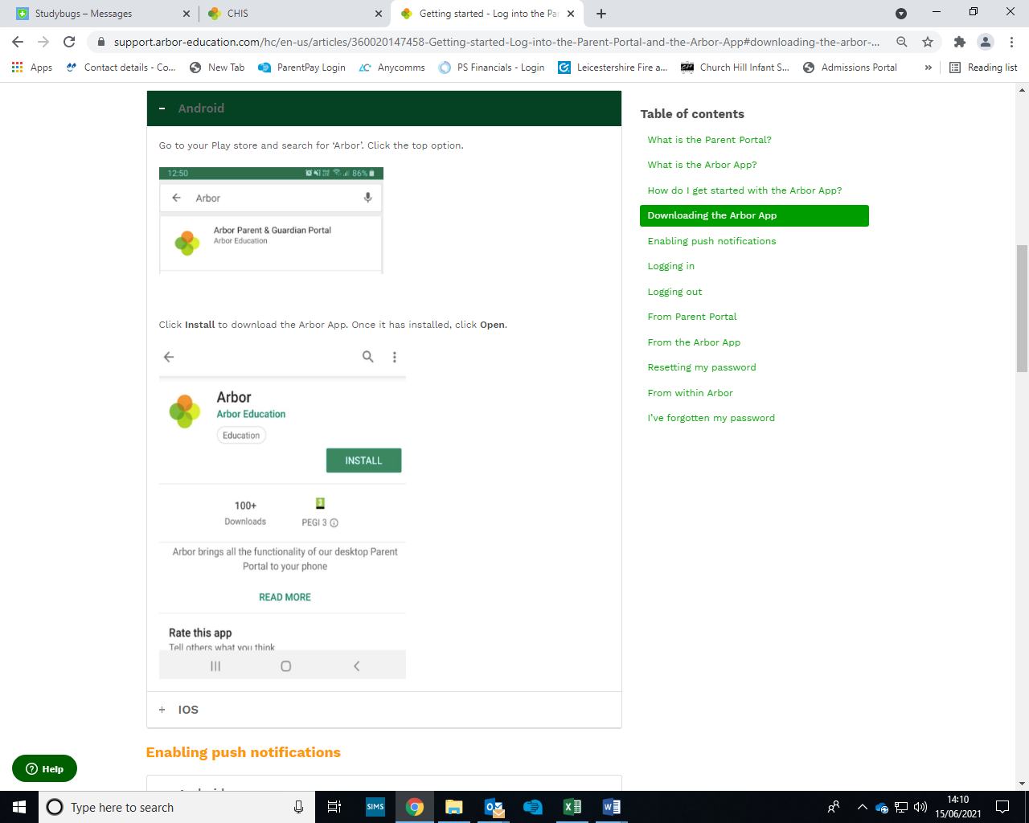
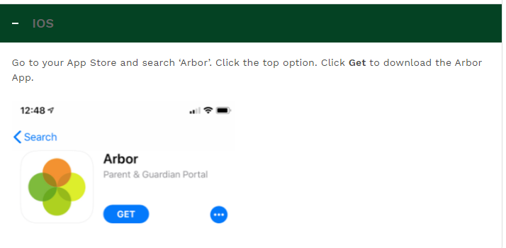

If you require any help with this process then please visit our school website to view Arbor’s helpful ‘Parent Guide’ at: https://www.churchhillinfants.bepschools.org/wp-content/uploads/sites/21/2021/06/The-Arbor-App-Usage-Guide-For-Guardians.pdf

Please do not hesitate to call the staff in the office who will be able to offer further guidance and support.

Yours faithfully,
Mrs Bulsara
Headteacher

